Homework 17

1.

5

/ \

5 6

/ /

8 7

2

/ \

5 6

\ /

8 7

2

/ \

5 7

/ \

8 5

2

/ \

5 6

\ /

5 7

2

/ \

5 6

/ /

8 7

2

/ \

5 6

/ \

8 5

2.

private static boolean satisfiesHeapOrdering(BinaryTree<Integer> t) {

boolean isHeap = true;

while (idx \* 2 + 2 > t.length && isHeap) {

if (t.at(idx) > t.at(idx \* 2 + 1) {

isHeap = false;

} else if (t.at(idx) > t.at(idx \* 2 + 2) {

isHeap = false;

}

idx++

}

return isHeap;

}

3.

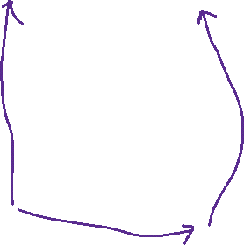

Location of <3,1,7> in queue